Thank you for buying a Noodlebox!

## a first noodle

Plug the supplied power adaptor into a mains outlet and fit the power plug into the socket at the top right of the noodlebox panel. Ensure the plug is firmly fitted in the socket then press and only the ON button. The red power LED comes on and a test pattern is shown on the screen. Keep the ON button held for about 3 seconds until the pattern completes and the screen below is shown

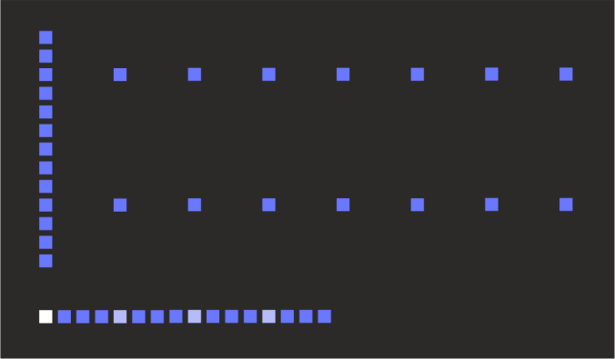

This is a **page,** where we can start to create a new sequence. Each page is made up of **32 steps**. The noodlebox screen shows all 32 steps of the page at once.

The pattern of dots along the bottom row of the screen is called the **loop ruler** and defines the **loop window**; the set of steps that will actually be played when the sequencer runs.

The active step (the one which is currently playing) is indicated on the loop ruler in full brightness. Initially this is the first step. Every fourth step along the ruler is indicated in medium brightness

The loop window starts out as the first 16 steps of the page. However, it can be set to any number of continuous steps up to the full page, and it can play in either direction.

The vertical bar shown at the left of the display is the **cursor**, which we use for the various editing functions. The cursor can be moved from left to right by turning the **encoder knob**.

The top 13 rows of the display (the height of the cursor) are where we enter the data values for each step. The two horizontal dotted lines that are already there are part of a grid showing the “C” notes at the start of each octave. These are to help you find your way around!

So, let’s enter a note… move the cursor into the middle of the loop window by turning the encoder knob to the right. Hold down the CV button and turn the encoder again. A bright point appears along the cursor (this is the note we added) together with a text box showing the name of the note (e.g. “A2” – the A note in octave 2). By keeping the CV button pressed and turning the encoder we can set the note to any pitch we like (see how the screen scrolls up and down when the note reaches the edge).

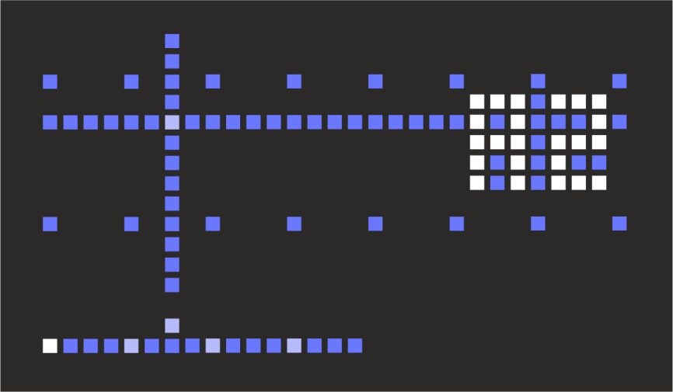

When we release the CV button, the note has been set. A new point has also been added at the bottom of the screen, just above the loop ruler – this is a **trigger point**, which indicates we’ll send a pulse to the gate output when this step is played.

We also now have a horizontal line spanning the whole display. This represents the control voltage (CV) output. Since we have only one note defined, the CV output will send the pitch CV for this note continuously (Pitch CV never “turns off”, it must always be set to something!)

Now add another point… move the cursor to a new position and hold CV and turn the encoder. Initially the note picks up the CV value in that column and we can then drag it around.

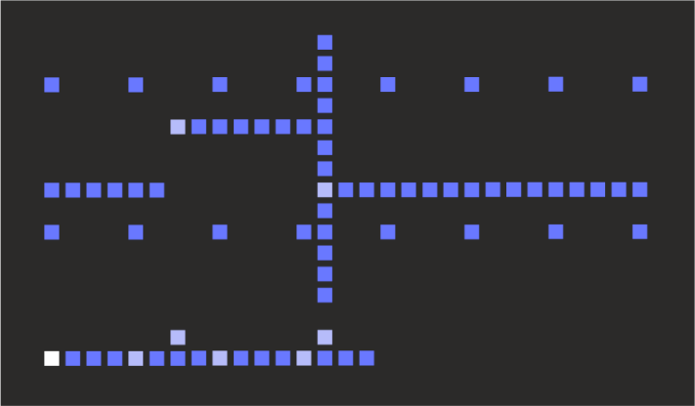

So here we have a sequence of A2 and E2 notes. The steps we actually edited are shown in a brighter colour to show that they are user-entered **data points.** The dimmer points follow the data points automatically and are called **fill points**.

Now let’s play this sequence… press the RUN button (above the encoder). Now we see the active step marker count along the loop window bar (and return back to the start when it reaches the end). The current data or fill point and trigger point (if any) are also shown in the brighter colour.

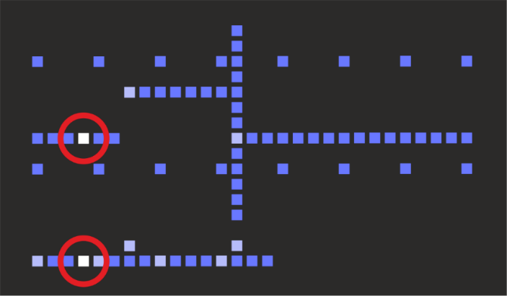

Patch up GATE 1 and CV A to your synth to hear it play! If you want to use the MIDI output, click the LAYER button to show the menu. Use the encoder to scroll down to the entry MID NONE and hold the CV button while turning the encoder to select MID NOTE. Now change the MIDI channel if needed. Press the LAYER button to return to the main display.

**Always Turn noodlebox off** by pressing and holding the OFF button until the screen shows the shutdown animation. This is the correct way to shut down the Noodlebox; it makes sure that any changes you have made to the configuration are saved. If you just pull the plug you will lose these changes.

# general operating conventions

Noodlebox packs a lot of functionality behind just 11 buttons and an encoder knob… We’ve tried to avoid too much menu diving but there are some special moves it will definitely help to know …

* When we say **click** a button we mean you just press and release it
* When we say **hold** a button we mean you keep it pressed down. This may be while you click another button or turn the encoder knob
* In some situations, the first four buttons (CV, GATE, CLONE, CLEAR) double up as **number keys 1, 2, 3, 4**. For example you can select layer 3 by holding LAYER and then clicking CLONE(3). The same applies for selecting pages A, B, C, D – for example you can select page B by holding PAGE and clicking GATE(2)`
* A lot of the ‘deeper’ noodlebox functions require **two buttons to be held** along with a turn of the encoder knob. The buttons must be pressed in the correct order and kept held down. For example, holding GATE then holding LOOP and turning the encoder adjusts gate retriggering. We’d mark this in the instructions as “GATE+LOOP”. The order is important - *holding* *GATE+LOOP is not the same as holding LOOP and pressing GATE… that would be LOOP+GATE*

As much as possible we’ve tried to keep the basic labels of each button easy to remember. For example, CLEAR+PAGE clears pages, GATE+RAND sets gate probability.

Learning these combinations might be a bit of a challenge, but we decided to go this way rather than menu diving, and we’ve tried to keep the most common functions accessible without needing combination of buttons. Hope that’s OK :)

* Above the encoder is the FN (function) button. This is mostly used in conjunction with the eight large buttons to access special settings.
* There are also two **menus**. They are only one level deep though and we tried to keep them short and easy to whizz through in a live situation. The **layer menu** is accessed by clicking LAYER. The **global menu** is accessed by holding FN and clicking LAYER.

When a menu is open, use the encoder to **select the menu option**, then hold the CV button and use the encoder to **change the value** of the option. Changes in menu settings are not applied until you release the CV button.